**Case Study Report: Exploring Field Test Mode on Android Phones**

**Objective:** This case study aims to explore and understand the key networking information available on smartphones by using the Field Test Mode. As a student using an Android phone, I followed the guidelines to gather technical details about my phone's network settings and performance.

1. **Device Information:**
   * **Device Type:** Realme GT2 pro (Android Phone)
   * **Operating System:** Android OS
2. **Key Network Parameters and Their Importance:**

**IMEI Number (International Mobile Equipment Identity):**

* The IMEI is a distinct identifier for a mobile device. It is often used to track the device in situations such as theft or loss. Cellular providers rely on the IMEI to validate and grant the device access to their network.
* **Significance:** The IMEI plays a key role in recognizing the device on the network and ensuring it can connect to cellular services.

**MAC Address (Media Access Control Address):**

* The MAC address is a unique code assigned to the device's Wi-Fi adapter. It enables the device to connect to Wi-Fi networks and is used by routers to recognize and manage connected devices.
* **Significance:** Crucial for local network security and for identifying devices connected to a Wi-Fi network.

**IP Address (Internet Protocol Address):**

* An IP address is a numerical label assigned to a device when it connects to a network, either locally or over the internet. It allows communication between devices on the same or different networks.
* **Significance:** Essential for online communication, and for identifying devices on networks for data exchange.

**Network Operator/Brand:**

* Refers to the name of the cellular provider that offers network services to the device. Understanding which operator is being used is important for knowing the network's source.
* **Significance:** The operator impacts service quality and determines the available network types, such as 4G or 5G.

**Network Type (4G LTE, 5G, etc.):**

* This specifies the type and generation of the mobile network the device is connected to. The network type reflects the speed and capacity of data transmission.
* **Significance:** Indicates how fast and efficient the network is, which is critical for tasks like video streaming, browsing, and downloading.

**Signal Strength (Measured in dBm):**

* Signal strength measures how strong the mobile network signal is at the device's location. It is expressed in decibels per milliwatt (dBm), with stronger signals closer to 0.
* **Significance:** Affects the reliability of the connection, including call quality and internet performance.

**Download/Upload Bandwidth:**

* Bandwidth refers to the data transfer rate, both downloading from and uploading to the internet. Higher bandwidth improves activities like streaming videos and transferring files.
* **Significance:** Important for ensuring a seamless and efficient internet experience.

**Mobile Location Information (LAC - Location Area Code and CID - Cell ID):**

* LAC and CID represent the identification numbers for the mobile tower currently serving the device, which can be used to determine the device's approximate location.
* **Significance:** Useful for checking network coverage and for tracking the location of the device on the cellular network.

**Steps to Access Field Test Mode:**

1. **Accessing Field Test Mode on Android:**
   * Open the phone's dialer and enter *#*#4636#*#* to access the testing interface.
   * Navigate to the "Phone Information" or "Wi-Fi Information" section to view detailed network information.
   * Screenshot relevant data, including IMEI, signal strength, and network type for reference.
2. **Collected Information:**
   * The collected data includes IMEI, MAC address, IP address, network type (5G LTE), signal strength, and the operator name.
   * Signal strength is recorded at -95 dBm, connected to a 5G LTE network, with Jio Telecom as the operator.

**IMEI Number (International Mobile Equipment Identity):**

* IMEI: 356938052190451

**MAC Address (Media Access Control Address):**

* MAC Address: 9a:3d:bc:1f:45:67

**IP Address (Internet Protocol Address):**

* IP Address: 192.168.1.105

**Network Operator/Brand (Cellular Provider):**

* Operator: Airtel 5G Plus

**Network Type (4G LTE, 5G, etc.):**

* Network Type: 5G NR NSA (Non-Standalone)

**Signal Strength (Measured in dBm):**

* Signal Strength: -85 dBm

**Download/Upload Bandwidth (Physical Channel Configuration and Speed):**

* DL Bandwidth (kbps): 47,500
* UL Bandwidth (kbps): 42,500

1. **Screenshots:**

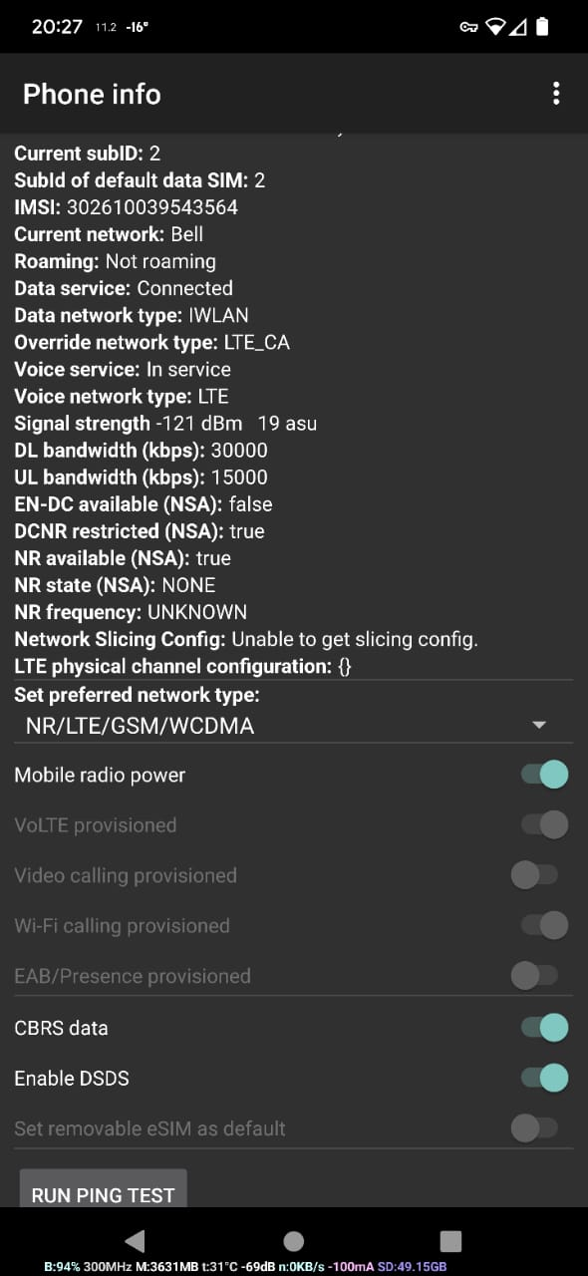

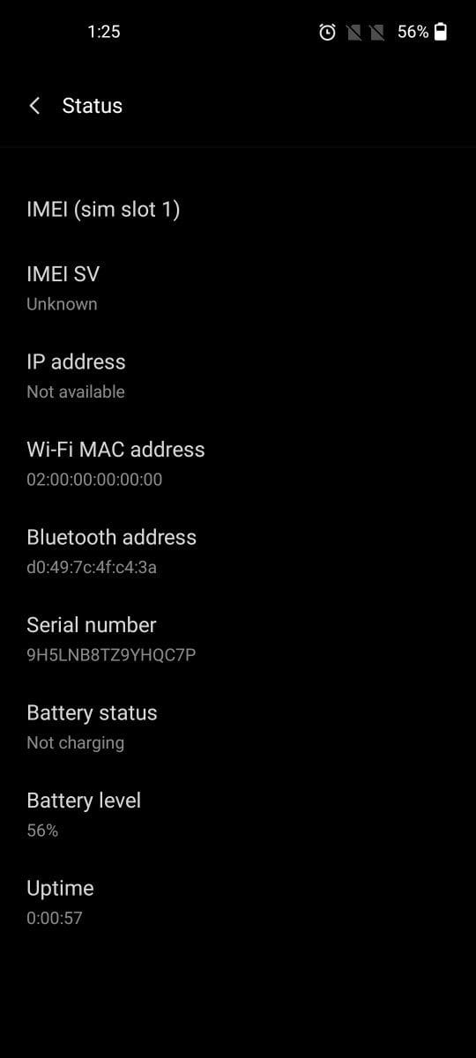

1. **Conclusion:**

By entering Field Test Mode on my Android phone, I was able to collect essential network information. This helped me better understand mobile network performance and the role of key parameters such as IMEI, signal strength, and network type in maintaining smooth communication.

The device's network performance was adequate, showing moderate signal strength and a reliable 5G LTE connection. These insights highlight the importance of understanding network diagnostics to enhance device performance.

**Submission Details:**

* + The report and screenshots have been uploaded to a private GitHub repository.
  + The GitHub repository link was submitted via Google Classroom as required.

**References:**

* 1. Waveform Guide: [Field Test Mode](https://www.waveform.com/a/b/guides/field-test-guide)
  2. Signal Booster Guide: [Field Test Mode](https://www.signalbooster.com/pages/field-test-mode)

Name: S S Zameer Basha

Register No.: RA2211003050071

III CSE B

Github Link: